Backpack Directions
Materials needed: 1 yard material (cotton/woven), 2-3yd cording, thread & 1 button
Step 1:
First step is to cut the pocket. You can make it any size you want, but no smaller than 7" X 8" and no larger than 10" X 10". To do this, cut 10" off your material- you should have 24 to 26 inches left for your bag. Now cut your pocket to your desired width. Next, cut on the fold of your remaining material. You should now have two pieces of material that measure approximately 22" X 24", and a pocket. Serge each side of the three rectangles- do not cut off any fabric.
Step 2:
If you choose to embroider your pocket, now is the time to do that. Follow directions on the embroidery machine. Press the top side of your pocket down 1", and the other 3 sides down 1/2". Be sure your pressing is exact. In the bottom corners of the pocket create a mitered corner.

Step 3:
Create a button hole in your pocket. You can do it vertically or horizontally. Use the button hole feature on your sewing machine to do this, but first mark your button hole space. The length of your button holes should be the diameter of your button plus the width of your button. Then cut open your button hole.

Step 4:
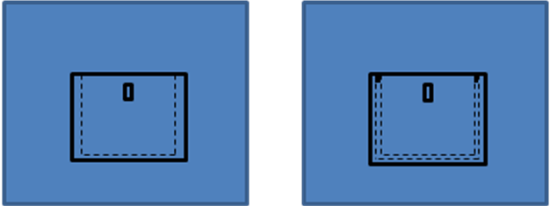
Place you pocket on your bag in the spot you want it. Sew the sides and bottom of the pocket 1/4" from the edge of the pocket to your bag- be sure to pivot!! Sew the sides and bottom of the pocket again 1/8" from the edge. Reinforce the pocket with reinforced pocket tops by turning your stitch length to .5 and your stitch width to a 2. Stitch between the two seams at the top of the pocket. Now center your button under your button hole and sew it in place.
Step 5:
Place your bag front and bag back together with pretty sides touching. You should now have a square that is approximately 22" X 24" long- the pocket should be between the two pretty sides. Pin the sides together matching the sides perfectly. Using a 5/8" seam allowance, sew the bottom of the bag together. Then, sew 5/8" seam allowance the bag together at the sides starting at the top of the bag and stopping about 3/4" from the bottom seam of the bag. Press the side seams open.

Step 6:
Now it is time to make the casing. Press the top edge of the bag down 1" to the inside of the bag- be sure to measure your drawstring. Now straighten (unfold) the edge again. Mark the button holes for the drawstring on each side seam. Sew the button holes, then cut them open.

Step 7:
Fold the casing back down and sew it in place just below the button holes. Turn your bag pretty side out. Use a safety pin to pull your cord or drawstring through the casing. Start with one length of cord and go through a button hole. Work your way through until you come out of the other button hole on the same side as you went in. Then start your second length of cord through on the other side. Stick the ends of the cord in the hole at the bottom of your bag and sew closed the seam.

Step 8:
Your bag should be complete! Take time to press it nicely. Fill out the evaluation sheet- grade yourself. Once you have given yourself a grade, bring your evaluation and your project to Mrs. Barnum to pass it off!

